Acids, Alkalis and Bases: An Introduction

Screen | Text for Student |  |  |  | Images and Text for Developer
Dissociation | Each molecule of water (H₂O) is made of two hydrogen atoms and one oxygen atom. |  |  |  | 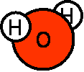Show movement of H+ to…
 | Unless they are frozen into ice, water molecules don’t always stay stuck together. They are always splitting apart into then reforming again. This is called dissociation. H₂O splits into two ions: OH⁻ (or hydroxide) ions and H⁺ (hydrogen ions; sometimes also called protons). |  |  |  |  |  |  |  | 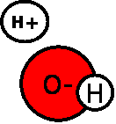Show H+ ions and OH- ions. As they split apart the charge symbol appears on the ion. When they reform, the charge symbol disappears.
The pH Scale | In pure water, for every dissociated H+ there is a OH- ion. In other words, the ratio of H+ to OH- is always 1:1 (1).  In 1909, a chemist called Sørensen devised a system of measuring the amount of free H+ ions in a solution. He called it the pH scale because, in German, potenz Hydrogen means “Hydrogen concentration”.  Sørensen’s scale ran from 0 to 14. He based it on pure water, which he placed in the middle at pH 7.  Solutions with a pH of 7 are neutral. This means that for every H+ ion in solution there is a matching OH- ion. |  |  |  | Perhaps the single H20 molecule should decrease in size to reveal others around it and they are contained within a beaker of water …  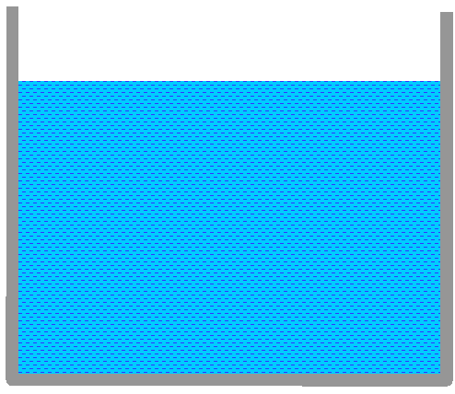  The animation of them dissociating and reforming continues as above. As (1) the bar chart should appear to show the 1:1 ratio and the animation beneath, where the OH- and H+ pile up.  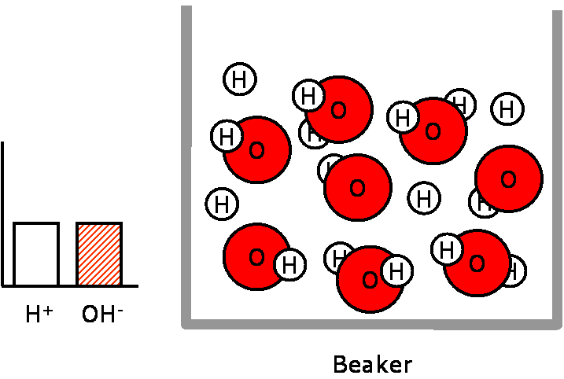  Show animation of all the H₂O molecules separating then pile the H up one side and the OH up next to them to show that there is the same amount of each.  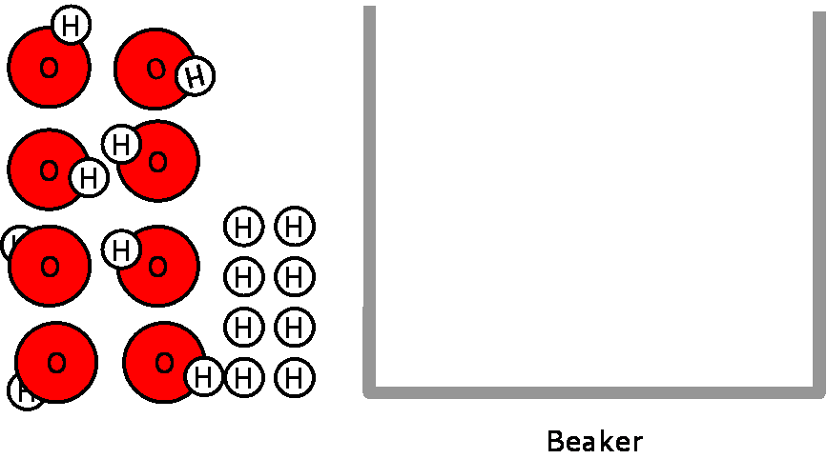
 | In the diagram on the right, you can see:  An empty beaker  A line representing the pH scale  and a bar graph, showing the relative concentrations of H⁺ and OH⁻ ions |  |  |  | 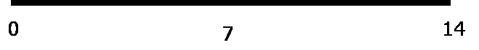  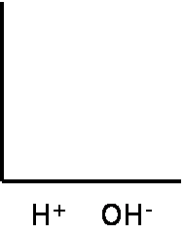  Highlight these as they appear in the text either with labels or just by their appearance: Beaker / Ph Scale / Axes representing relative concentrations of H+ and OH-
 | When pure water is added to the beaker there are equal number of H+ and OH-.  The pH of pure water is 7 or neutral. |  | 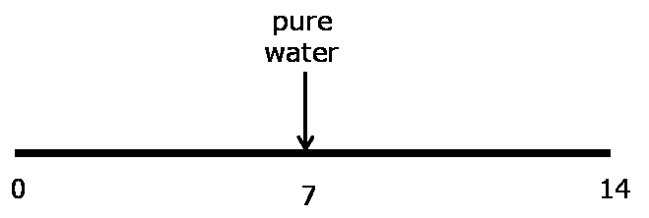  Animation: Show the bars for the H and OH rise at the same time to the same level as the water molecules are added to the beaker. Have an arrow appear on the sliding scale at pH 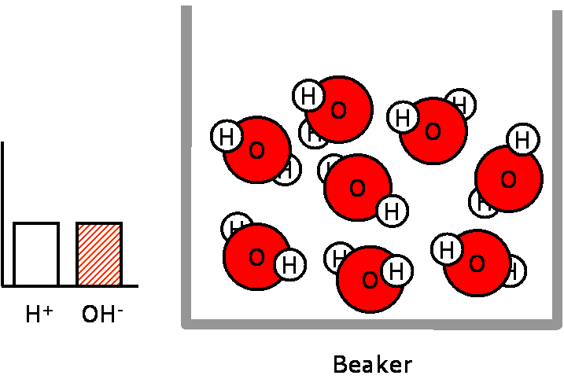
Acidic Solutions | If extra H+ ions are added to the beaker, what will happen to the solution?  [interactive] Drag the bars of the bar chart to indicate what will happen to the relative concentrations of H+ and OH-. |  |  |  | Animation shows more H+ ions being added to the beaker. They should be highlighted as being free – maybe by glowing briefly?  The bar chart should flash or draw attention it itself. This is a student interactive element: They should drag the red bar higher up the y axis.  The OH- bar must not be drag down-able. If this is tried, a message saying “Nothing has been taken out of the solution, try changing the ratio another way” could appear.  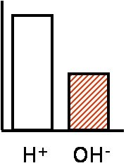  There might need to be a “help!” box which, when clicked, shows the message “Alter the bars on this graph to show that there are more H+ in the solution”.
 | Any solution with more H+ than OH- is said to contain free H+ ions and is acidic.  [interactive] On the pH scale, drag the arrow to indicate the range for acids.  The definition of an acid is: “A substance with free hydrogen ions (H+) in solution.”  Acids have a pH < (less than) 7. |  |  |  | Show the litmus colours underneath the bar. The arrow should be dragged to the left towards 0.  If the student does this then display message: Yes, that’s right! Acids fall within the pH range from 0-6.9. The lower the pH number, the more free H+ and the stronger the acid. That is because the pH scale is an indirect scale of measurement.  If they do not, display message: Bad Luck! More free H+ ions in solution does not mean that the pH value is larger. In fact the opposite is true… try again!  There is then the option to drag the arrow to the left.  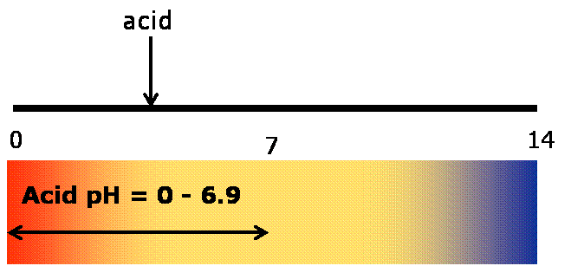
Alkaline Solutions | The definition of an alkali is: “A substance with free hydroxide ions (OH-) in solution (1).  [interactive] Move the bars on the bar chart (on the right) to illustrate the difference in OH- and H+ ratios in an alkaline solution.  [interactive] Bearing this in mind, drag the arrow along the line to illustrate the pH range for alkalis. |  |  |  | 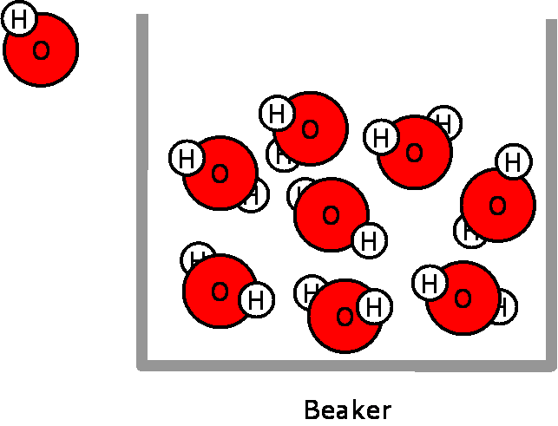  [As text (1) is said, animation should show more OH- being added to the beaker. The extra OH- should be highlighted as they drop into the beaker – maybe by glowing briefly?  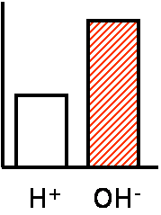  As the text is spoken, the bar chart flashes to draw attention to itself. It should be 1:1.  As above, the (H+) bar must not be drag down-able.  There should be a help box, or whatever as above for acids, which appears after a timed delay and which tells the student something like “Alter the bars on this graph to show that there are more H+ in the solution”.
 | [interactive] Now, on the pH scale, drag the arrow to indicate the range for alkalis.  [once the exercise has been done]  Remember: The pH scale indirectly measures the concentration of H+ ions in solution. Because alkalis have more OH- than H+ ions, their relative concentration of H+ is low and so the pH value will be high  For more information on direct and indirect measurement, click the tabs at the top of the screen. |  |  |  |  | 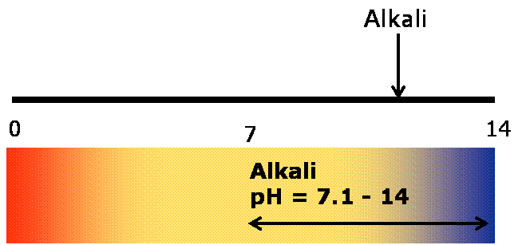  The arrow should be dragged to the right. If the student does not do this, display the incorrect response and then move the arrow to where it should be.  If they get it right…  “Yes, that’s right! Alkalis have a pH greater than 7.”  If they do not, display message: No, sorry. Try again! A pH less than 7 indicates that the solution is acidic.
Direct Measurement | Scales of measurement are often direct scales. This means that the value representing the quantity of an item is bigger, the more there is of that item.  The following is a simple example of direct measurement: Imagine you had 20 tablets (1). If you put five in each bottes you would have 20 ÷ 5 = 4 bottes (2).  However, if you had 40 tablets (3) and again bottled them in fives you would fill 40 ÷ 5 = 8 bottles (4).  So, as the amount tablets increases, the number of bottles needed to store them also increases (5). If you know the number of bottles then you could work out how many tablets you had, and vice versa. This is direct measurement. |  |  | Animations appear with the text …  20 tablets (1)  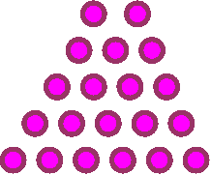  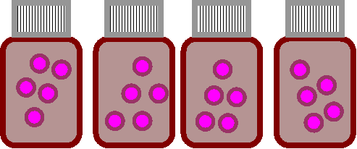 = 4 bottles (2)  40 tablets (3)  as 8 bottles (4)  (5) 80 tablets…. 16 bottles  160 tablets… 32 bottles.. [etc.]  [this text could come up to just ram the point home]
Indirect Measurement | The pH scale is also a scale of measurement. It measures the concentration of H+ ions in a solution in relation to a number on the pH scale from 0-14.  However, it is a back-to-front or inverse scale. This means that the more H+ ions there are in solution, the smaller the pH value number for that soultion.  [interactive] Move the OH- and H+ ions in and out of the beaker on the right and see what happens to the pH value. |  |  |  |  |  | 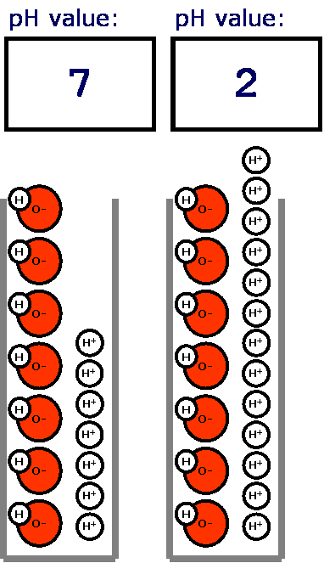  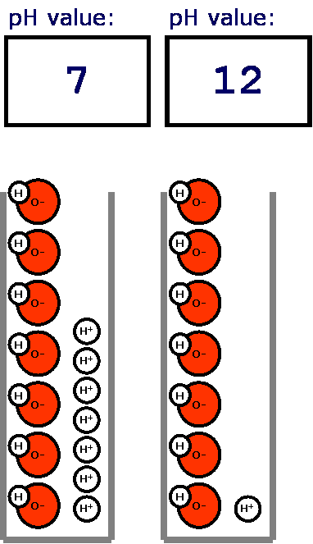  This diagram shows a beaker and a pH counter. For each each OH- or H+ that is removed or added the counter moves 2 points up or down.
Bases | What about bases though? Day-to-day, the term “base” is often used interchangeably with the word “alkali”.  Although their methods are slightly different, both alkalis and bases increase the pH value of a solution by reducing the concentration of H+.  To illustrate the differences in the action of alkalis and bases, have a look at the picture on the right of a beaker of acid (1). Note that there are more H+ ions than OH- ions (2). [interactive] Click on the flask to add alkali, or free OH- ions, into this solution (3). The solution is initially neutralised, then as more alkali is added, it becomes alkaline. |  |  |  |  |  |  | 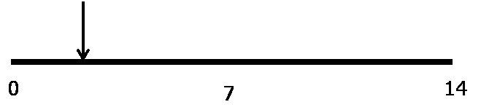  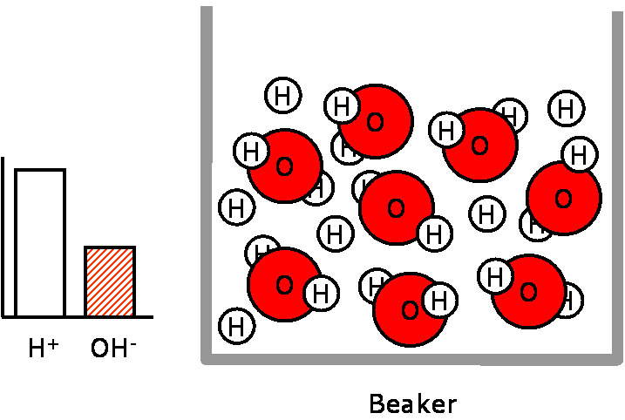  (1) Show beaker with acid soln. Highlight the free H+ as the text appears (2). Draw a flask of alkali and then as it tips up, OH- fall into the beaker (3). As more OH- are added, the pH scale moves to the right and the bars level off. Stop when the solution is neutral and flash up “ph=7, OH-:H+ = 1:1” or similar. If more alkali is added then move arrow to right/ OH- bar higher.  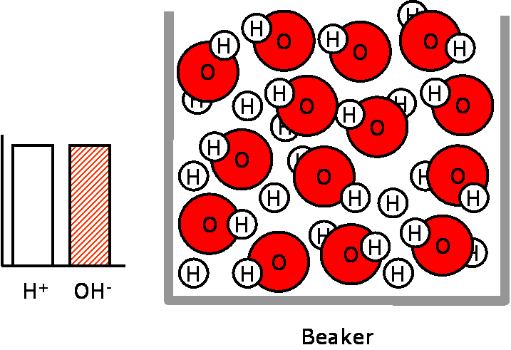
5b | A base, however, is a molecule other than a OH- ion which can bind to free H+ ion.  So, a basic solution does not add more OH- ions to the solution, it just removes the extra H+ ions.  [interactive] Click on the flask containing a base and see what happens (1).  Note that the concentration of H+ decreases but the concentration of OH- does not increase (2). | (1) A flask containing “base” appears. As the student clicks on it the molecules pour into the beaker (2). There needs to be some flash/glow effect as the H+ bind with the base. The arrow moves to the right (as above) and the bar chart H+ bar drops.  